

**Faculty of Engineering and Technology**

**Department of Electrical and Computer Engineering**

**ENCS4370**

**COMPUTER ARCHITECTURE**

**Project 1**

**Prepared by:**

**Name: Shireen Hamdeh**

**Number: 1200208**

**Instructor: Dr. Aziz Qaroush**

**Section: 2**

**Name: Rewaa Assi**

**Number: 1201419**

**Instructor: Dr. Ayman Hroub**

**Section: 1**

**Table of Contents**

Calendar Project 1

Option One 2

Per day 2

Per set of days 3

A given slot in a given day 3

Option 2 4

Number of Lectures 4

Number of Office Hour 4

Number of Meetings 5

Average of Lectures per day 5

Ratio between Number of Lectures and Number of OH 5

Option Three 6

Add at Empty Day 6

Add at Middle 7

Add at Start 8

Add at End 9

Conflict 10

Option Four 10

Delete at Start 10

Delete from Empty Day 11

Delete at Middle 12

Delete at End 13

Conflict 14

Option 5 14

**Table of Table**

Table 1: File before Start Testing 1

**Table of Figure**

Figure 1: Option Menu 2

Figure 2: Option 1 Menu 2

Figure 3: Per Day Result 2

Figure 4: Option 1: Start and End Hour 3

Figure 5: Resulted Values 3

Figure 6: Option 2 Menu 4

Figure 7: Resulted Value 4

Figure 8: Resulted Value 4

Figure 9: Resulted Value 5

Figure 10: Average of Lectures per day 5

Figure 11: Ratio between Number of Lectures and Number of OH 5

Figure 12: Needed Information 6

Figure 13: Resulted Day Reservation 6

Figure 14: Modified Calendar 6

Figure 15: Entered Value at Day number 2 7

Figure 16: Middle insert 7

Figure 17: Modified Calendar 7

Figure 18: Entered Values at Day number 5 8

Figure 19: Resulted Reservation Slot 8

Figure 20: Modified Calendar 8

Figure 21: Entered Information of day number 1 9

Figure 22: Resulted Reservation Slot 9

Figure 23: Modified Calendar 9

Figure 24: Addition Conflict 10

Figure 25: Required information to delete 8-9L slot 10

Figure 26: Resulted day Reservation 10

Figure 27: Modified Calendar 11

Figure 28: Delete from Empty Day 11

Figure 29: Delete Information 12

Figure 30: Deleted Slot 12

Figure 31: Modified Calendar 12

Figure 32: Delete Information 13

Figure 33: Deleted Slot 13

Figure 34: Modified Calendar 13

Figure 35: Delete Conflict 14

Figure 36: No Change in Conflict 14

Figure 37: Exit 14

# Calendar Project

In this project, we construct a calendar program that saved in a file, as shown below

Table 1: File before Start Testing

|  |
| --- |
| 1:8-9L,10-12M,1-3OH  2:8-9L,10-12OH,12-3M  3:  4:8-9M,11-2OH  5:4-5M  6:  7:  8:  9:  10:8-9L,2-4M  11:8-9L,10-12OH,2-4M  12:8-9L,10-11OH,3-4M  13:  14:  15:  16:  17:  18:  19:  20:  21:8-9L,10-12OH  22:  23:  24:  25:  26:  27:  28:  29:  30:  31: |

The project support view, add and delete options as shown:

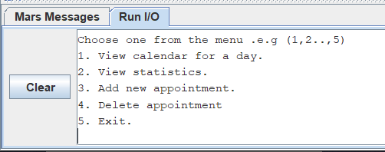

Figure 1: Option Menu

## Option One

If we choose option 1, this options will appears

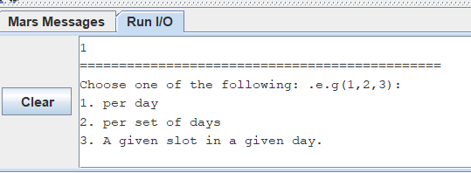

Figure 2: Option 1 Menu

### Per day

For example, if we want to print day number 1, this result will appear:

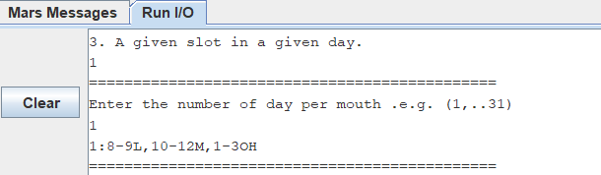

Figure 3: Per Day Result

### Per set of days

For example, if we want to print set of day with numbers 1, 3, 5, this result will appear

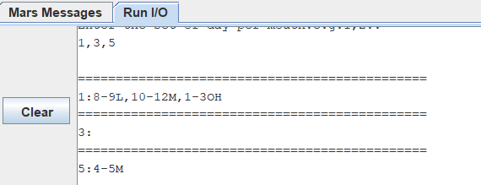

### A given slot in a given day

For example if we want to know what we have form [9-12] as shown below.

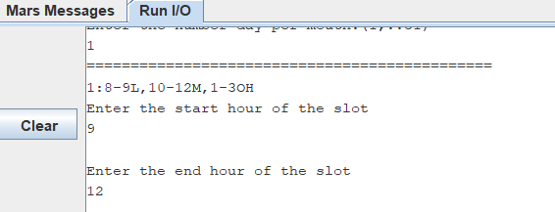

Figure 4: Option 1: Start and End Hour

This result will appear as expected.

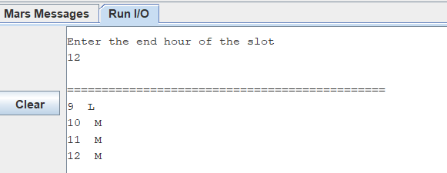

Figure 5: Resulted Values

## Option 2

If we choose option 2, this options will appears

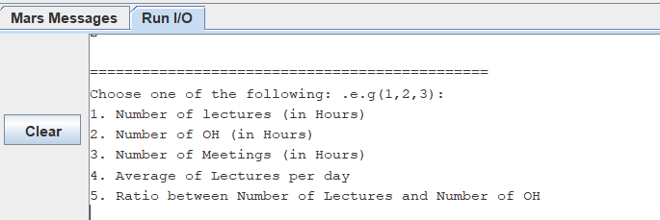

Figure 6: Option 2 Menu

### Number of Lectures

Figure7 shows he resulted number of lecture as expected since we have a lecture in these days (1, 2, 10, 11, 12, 21) which shown in Table 1 (File).

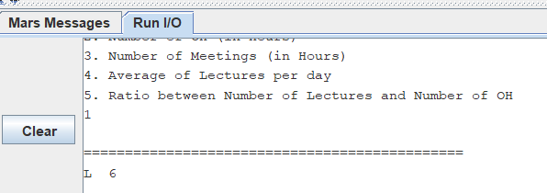

Figure 7: Resulted Value

### Number of Office Hour

Figure 8 shows he resulted number of office hours as expected as shown in Table 1 (File).

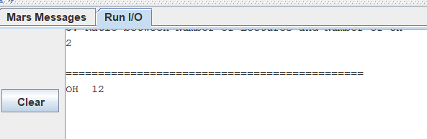

Figure 8: Resulted Value

### Number of Meetings

Figure 9 shows he resulted number of office hours as expected as shown in Table 1 (File).

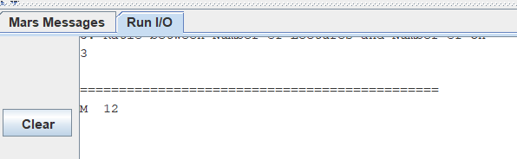

Figure 9: Resulted Value

### Average of Lectures per day

Figure 10 shows Average of Lectures per day since we have 8 reserved days and 6 lectures 6/8 = 0.75.

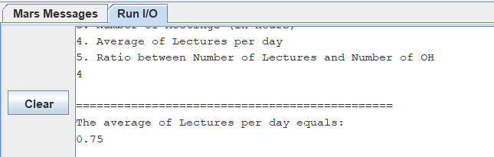

Figure 10: Average of Lectures per day

### Ratio between Number of Lectures and Number of OH

Since L=6 and OH=12 then L/OH = 0.5 as shown below.

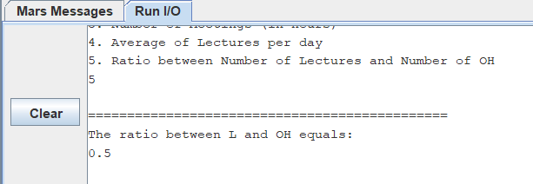

Figure 11: Ratio between Number of Lectures and Number of OH

## Option Three

### Add at Empty Day

Figure 12 shows the information needed to add 8-9M to empty day (day number 7)

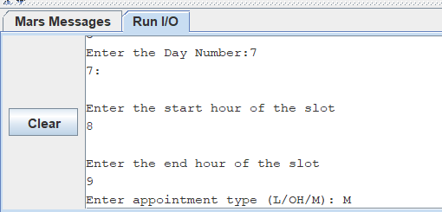

Figure 12: Needed Information

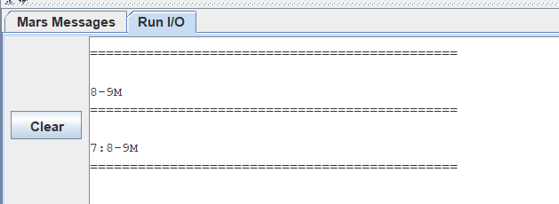

Figure 13: Resulted Day Reservation

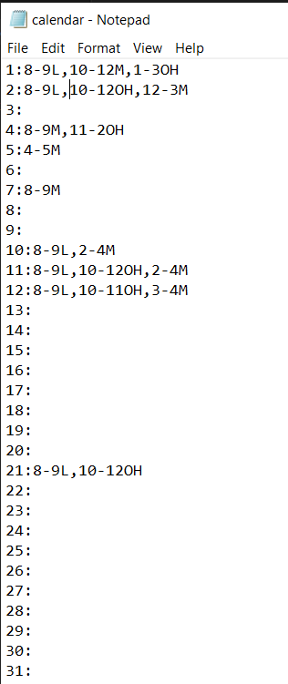

Figure 14: Modified Calendar

### Add at Middle

For Example if we want to add 9-10M to day number 2, as shown below

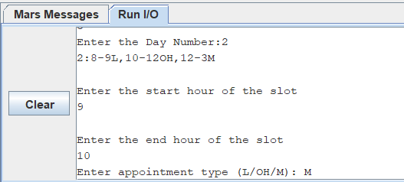

Figure 15: Entered Value at Day number 2

Figure below shows the insertion at middle which successfully happened.

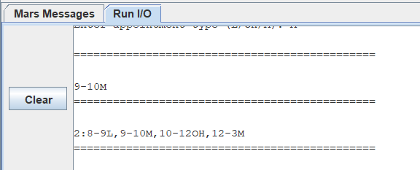

Figure 16: Middle insert

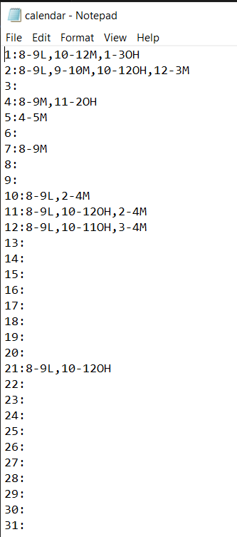

Figure 17: Modified Calendar

### Add at Start

Figure 18 shows the required information to add a new slot 10-12L to day number 5.

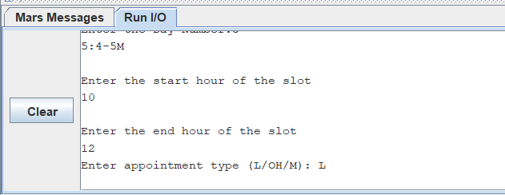

Figure 18: Entered Values at Day number 5

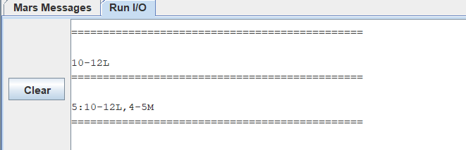

Figure 19: Resulted Reservation Slot

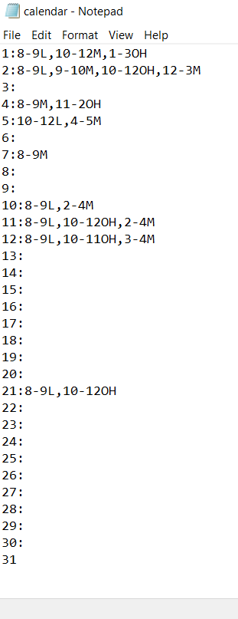

Figure 20: Modified Calendar

### Add at End

Figure 21 shows the required information to add a new slot 10-12L to day number 5.

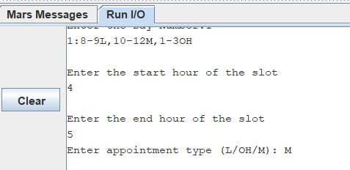

Figure 21: Entered Information of day number 1

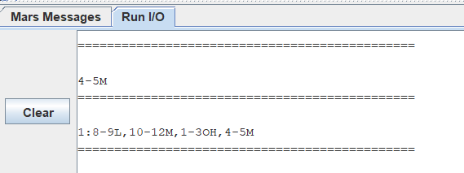

Figure 22: Resulted Reservation Slot

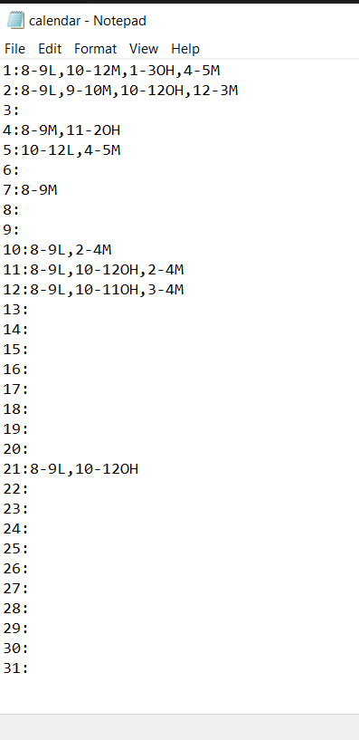

Figure 23: Modified Calendar

### Conflict

Figure 24 shows a conflict.

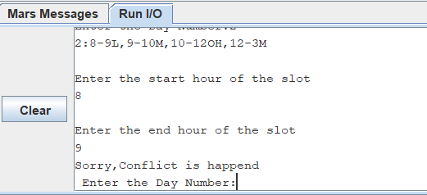

Figure 24: Addition Conflict

## Option Four

### Delete at Start

Figure 25 shows the required information for delete 8-9L slot.

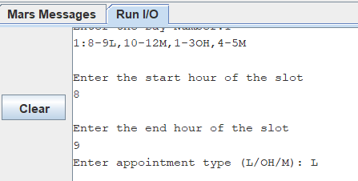

Figure 25: Required information to delete 8-9L slot

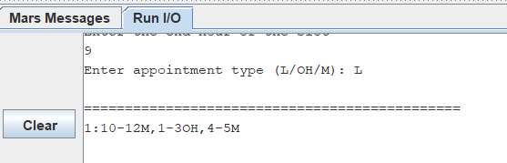

Figure 26: Resulted day Reservation

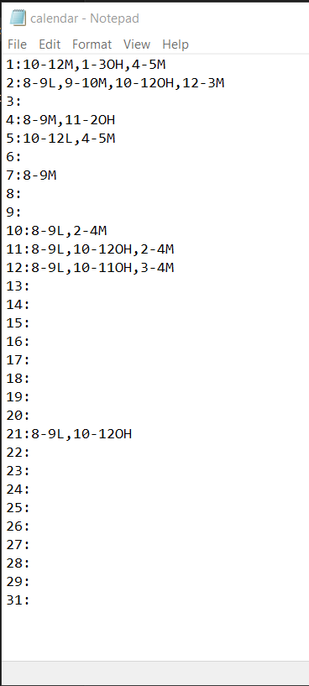

Figure 27: Modified Calendar

### Delete from Empty Day

Figure 28 shows the deletion from an empty day.

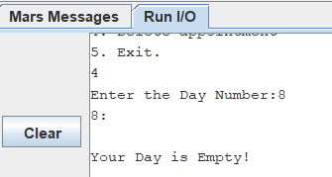

Figure 28: Delete from Empty Day

### Delete at Middle

Figure 29 shows the required information for delete 10-11OH slot.

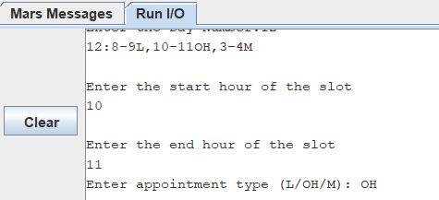

Figure 29: Delete Information

Figure 30 shows the deleted slot as expected.

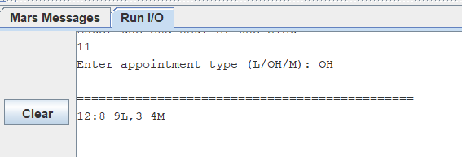

Figure 30: Deleted Slot

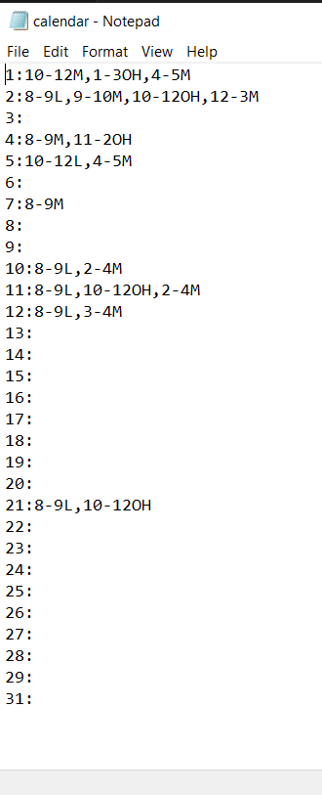

Figure 31: Modified Calendar

### Delete at End

Figure 32 shows the required information for delete 2-4M slot.

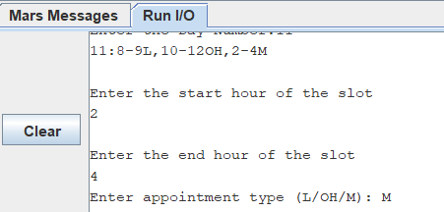

Figure 32: Delete Information

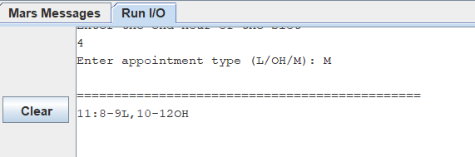

Figure 33: Deleted Slot

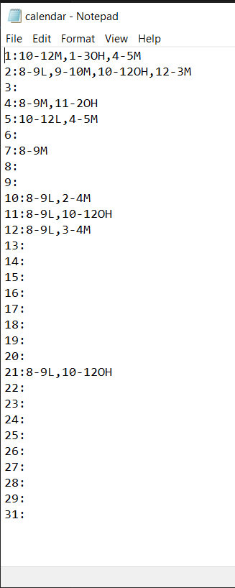

Figure 34: Modified Calendar

### Conflict

Figure 36 shows a delete conflict.

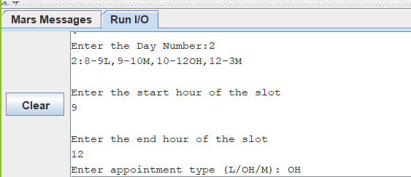

Figure 35: Delete Conflict

Note that the day reservation is still the same as shown below.

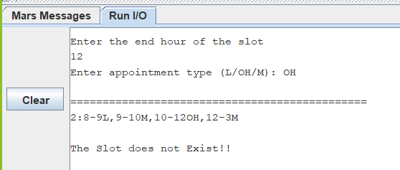

Figure 36: No Change in Conflict

## Option 5

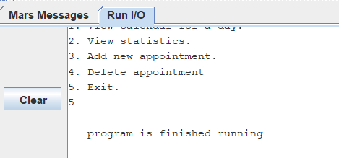

Figure 37: Exit